

**THIRD BRIDGE AUTOMATION USING SELENIUM & bdd**



**Revision History**

|  |  |  |  |  |
| --- | --- | --- | --- | --- |
| **Version** | **Created on** | **Published on** | **Created By** | **Reviewed By** |
| 1.0 | 17-05-2017 | 18-05-2017 | Anuj Kataria | Deepak Kashyap |

Table of Contents

|  |  |  |
| --- | --- | --- |
| **S.No.** | **Content** | **Page No** |
| 1 | Document Guidance | 3 |
| 2 | Prerequisites | 3 |
| 3 | Test Scenarios Covered | 5 |
| 4 | Extracting Project from RAR file | 5 |
| 5 | Importing Test Project in Eclipse | 5 |
| 6 | Project Structure | 6 |
| 7 | Browser Selection | 6 |
| 8 | Test Execution | 7 |
| 9 | Results | 8 |

**Document Guidance:**

1. Prerequisites
2. Install JAVA – JDK.
3. Install Eclipse
4. Install Maven.
5. Test Scenarios Covered.
6. Extract the Test Project from RAR file.
7. Import the Test Project in Eclipse.
8. Project Structure.
9. Browser Selection (Chrome, Firefox or Headless – PhantomJS).
10. Execute the Tests through Command Line using Maven.
11. Results (HTML Reports).

**Prerequisites:**

**Installation of JAVA – JDK:**

* **JAVA download**: Open any browser enter the URL – <http://www.oracle.com/technetwork/java/javase/downloads/index.html> . This would open the official JAVA website to download the latest JAVA – JDK version on your system. Refer the following figure.

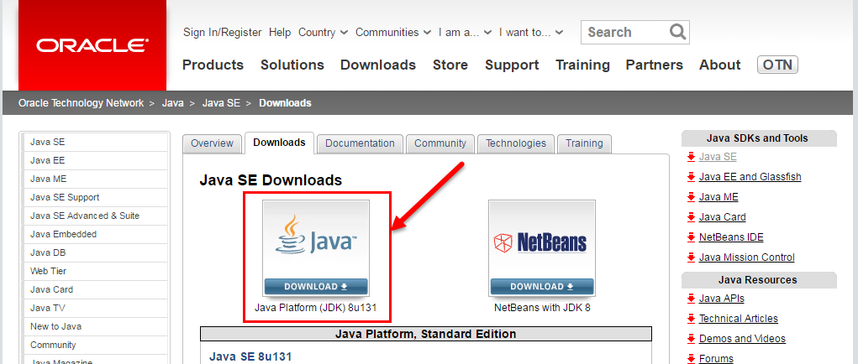

* As soon as we click on the above link, it will ask you to Accept the License Agreement. Click the Radio button to accept the License Terms.

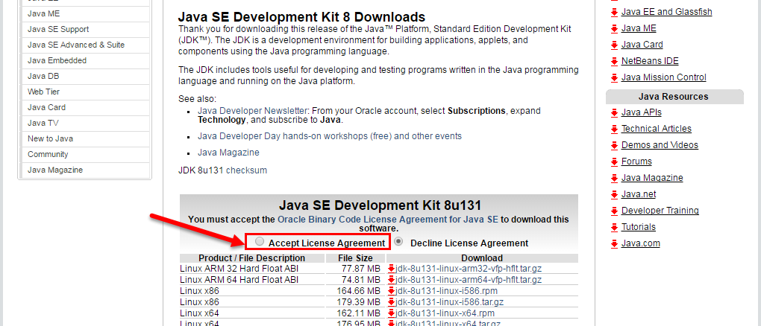

* After that click on red download button against your operating system which you are using and it will start the download.

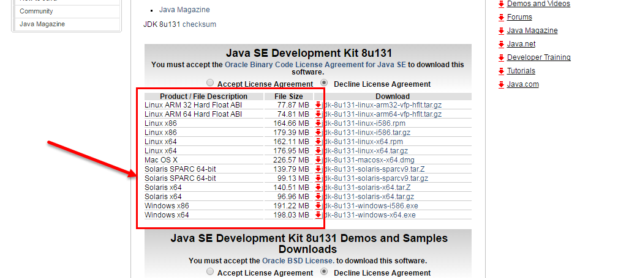

* After that double click to open the downloaded file and follow the steps to install JAVA – JDK.
* Also, Set Environment Variables for JAVA. For details refer to this link <https://www.tutorialspoint.com/java/java_environment_setup.htm> .

**Installation of Eclipse:**

* **Eclipse Download**: Open any browser enter the URL – <https://www.eclipse.org/downloads/> .This would open the official Eclipse website to download the latest version of eclipse.
* **Click on Download and it will download a RAR file of Eclipse. (Please check for your version of operating system 32 or 64 bit and navigate in the website accordingly the relevant Eclipse download).**
* After that Extract the RAR file of Eclipse and open the **“eclipse.exe”** file from the folder **“eclipse-jee-mars-2-win32-x86_64 > eclipse”**.

**Installation of Maven:**

* **Maven Download**: Open any browser enter the URL – <https://maven.apache.org/download.cgi> . This would open the official Maven website to download the latest version of maven.
* Click on the **”Binary zip archive”** link i.e. **“apache-maven-3.5.0-bin.zip”** to download the file.
* Extract the zip file to your preferred location.
* Also, Set Environment Variables for Maven. For details refer to this link <https://www.tutorialspoint.com/maven/maven_environment_setup.htm> .

**Test Scenarios Covered:**

|  |  |  |  |
| --- | --- | --- | --- |
| **S.No.** | **Modules** | **Number of Test Scenarios** | **Number of Test Scenarios Automated** |
| 1 | Login Process | 1 | 1 |
| 2 | Registration Process | 1 | 1 |
| 3 | Create a new blog, create a test post and check whether the preview is working fine. | 1 | 1 |

**Extracting Test Project from RAR file:**

* Save the provided **ThirdBridgePOC.rar** file in a location.
* Right click on the RAR file and click on “Extract Here”.
* Provide preferred destination path and click on OK on the window.

**Importing Test Project in Eclipse:**

* After you open Eclipse, click on File menu and select Import.
* In the pop up window, select **”Existing Projects into Workspace”** under General tab and click next.
* The Project will now be visible in Eclipse.

**Project Structure:**

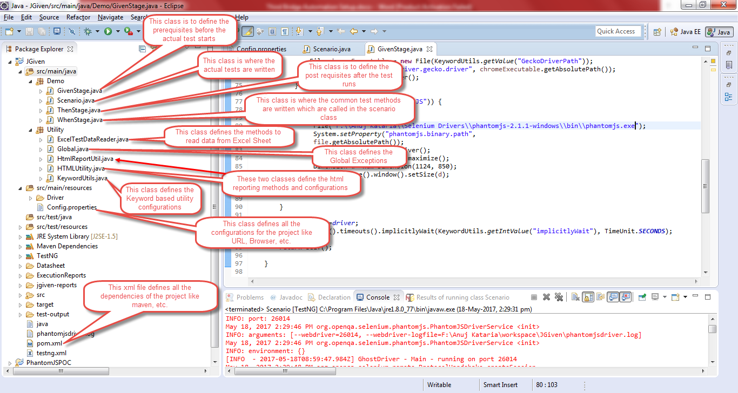

**Web Browser or Headless Browser (PhantomJS) Selection in Config File:**

* Open Config file in the project folder path as **"src\main\resources\Config.properties"** in notepad.
* Change the browser value to **“chrome”**, **“firefox”** or **“PhantomJS”** to run on your preferred browser.

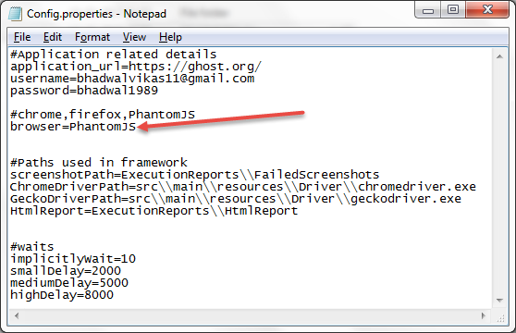

**Test Execution:**

* Open Command Prompt by typing “cmd” in the Run box and type the following commands:

1. “<drive letter where the project is saved>: and hit enter
2. “cd<space><path of the test project> and hit enter.
3. “mvn test” and hit enter.
4. It will start running the tests and generate the html report.

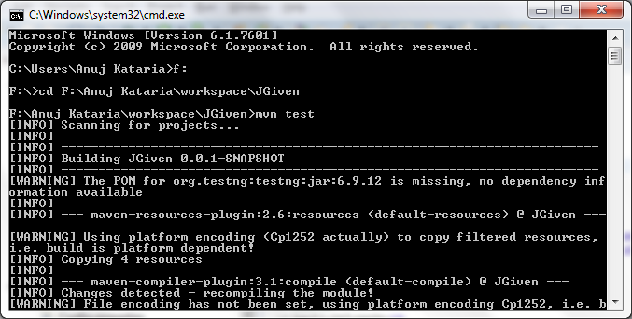

**Results (HTML Reports):**

* Once all the test cases are executed the html reports are generated in the project folder **"ExecutionReports\HtmlReport\TestReport.html"** as illustrated below.

